***Walk-through on the proposed Format of the Inter-Schools Bridge League.***

1. First, every school in the target area will be emailed the following Documents:

(a1) ***Modern Bridge Overview;***

(a2) ***MiniBridge Synopsis*** and;

(a3) ***Bridge League Format***.

1. An appreciation of Bridge, its benefits and a Global analysis of the game will also be available on the website, with references to established international reports;
2. Should the school be interested, they confirm their details and the level of interest via email. If entering the Competition – and this can be deferred – they remit the appropriate sum;
3. If further lessons are required, this is related to the Administrator;
4. All of these documents and the initial information videos will be on the [www.jgobrb.org](http://www.jgobrb.org) website, and;
5. Video lessons and samples of bidding and play will also be on the website, as will basic instructions for accessing RealBridge.

***Modern Bridge Overview.***

***Preamble.***

The game of Bridge in its current, ‘full’ format has existed for almost 100 years. It was devised to extend and amalgamate several card games in existence at that time by Harold Vanderbilt.

In essence, Vanderbilt determined that, being a very successful businessman, the new game should have a competitive edge before playing the cards, and so he devised the concept of ***Bidding*** to win the ***Contract*** – that is, the largest number of Tricks that the final bidder ***Declares*** he will make, and in what suit. Hence the title **Contract Bridge**.

***The Game Itself.***

In the actual play of Bridge, players play in pairs, and sit at a Table opposite each other, against another pair. These ‘positions’ are called North, South, East and West. All 52 cards are dealt, and the Dealer evaluates his cards. To add an extra layer of cerebral challenge, Vanderbilt decided that the passing of information between the partners must be ‘In Code’, and so we have the **Bidding System**. There are many of these Systems in place (the most common being Acol), and the players at the upper echelons of the game use some extremely complex structures to determine their best ‘fit’ between them.

In the simplest form, players use High Card Points:

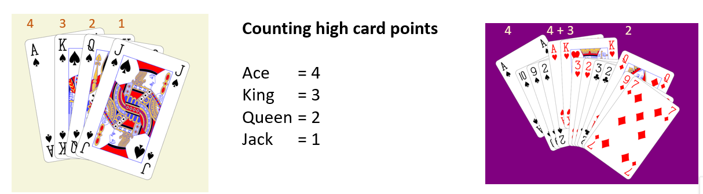

and that total, coupled with the ‘shape’ of the hand, determines whether or not they wish to enter the **Bidding** at all, and how far they wish to go. When the final, largest bid has been made, that Pair are the **Declarers**, and the first one of the Declarers to mention that chosen suit is the ***Declarer***. Play now begins. The person on the Declarer’s left chooses the card from his 13 as the opening lead, and Declarer’s partner places his cards face-up on the Table for all to see – this is called the ***Dummy***. Declarer plays from both hands, and dummy is now inactive. When all 13 cards are played, the number of Tricks made by Declarer determines the success or failure of the Contract. This result, in a Competition, is either recorded electronically, or entered into a Scoresheet which is hidden until the hand is played.

In a competition, the Pairs move around to all of the Tables and play against the other Pairs, with different Sets of Boards The number of Boards in a set will vary, and typically is dependent upon the number of Pairs playing. This competition is called ***Duplicate Contract Bridge***, and is the format used in most Bridge clubs.

***MiniBridge Synopsis***

***Preamble.***

In my humble opinion, Harold Vanderbilt started with what is now known as MiniBridge. While on a cruise with too much time on his hands, he decided that a complex, convoluted ***Bidding System*** would be more fun! Nonetheless, even without this complexity, MiniBridge still incorporates the concept of ***Bidding*** to win the ***Contract*** – that is, the largest number of Tricks that the final bidder ***Declares*** he will make, and in what suit. Thus the title **Contract Bridge** remains.

However, these Systems – again, in my opinion - can be a significant impediment to encouraging people to start out in Bridge. So, MiniBridge reverts to simply using High Card Points in determining who should have the Contract.

***The Game Itself.***

And so, in MiniBridge as in “Full” Bridge, players play in pairs, and sit at a Table opposite each other, against another pair. These ‘positions’ are called North, South, East and West. All 52 cards are dealt, and the Dealer counts and declares his High Card Points:



The other 3 pairs do likewise, and the pair with the biggest total are the Declarers. The player of the Declarers with the fewest points now places his cards face-up on the table – this is called the ***Dummy*** - and his partner now states how many tricks he will win, and in what suit (aka *denomination*).

Play now begins. The person on the Declarer’s left chooses the card from his 13 as the opening lead, and Declarer’s partner places his cards face-up on the Table for all to see – this is called the ***Dummy***. Declarer plays from both hands, as Dummy is now inactive. When all 13 cards are played, the number of Tricks made by Declarer determines the success or failure of the Contract. This result, in a Competition, is either recorded electronically, or entered into a Scoresheet which is hidden until the hand is played.

In a competition, the Pairs move around to all of the Tables and play against the other Pairs, with different Sets of Boards The number of Boards in a set will vary, and typically is dependent upon the number of Pairs playing. This competition is called ***Duplicate Contract Bridge***, and is the format used in most Bridge clubs.

***Bridge League Format***

***The Competitions.***

Possibly 6 separate ‘Grades’ of Competition. These are in MiniBridge and ‘Full’ Bridge, at Primary School, Secondary and Third-Level (University, etc.). After the first Year, these can be internally graded, as in the usual Masterpoints system.

There will be winners as individual Pairs, and Institutions as a composite – Best 3 Pairs Scores in a minimum of 3 sessions.

***The “Hook”.***

Each Institution can download basic Instructions in MiniBridge from the website. If deciding to go further, each Institution pays a Registration Fee for the Institution (this will vary according to size), and an entrance fee for each student which covers the cost of all the subsequent RealBridge sessions (for example 6). The Institution can then access extended Teaching videos of the fundamentals of Play and Scoring. Extra lessons – usually in the play of the cards - can be arranged (via Zoom) at a small extra cost.

The ***Hook*** is in the fact that any school that so desires can acquire, completely free, basic lessons in MiniBridge. They can also participate for a very minimal fee in the RealBridge sessions, but will not – obviously – be an actual Competitor in the Hillery Cup (working title!) until they register. Also, JGOBRB will happily facilitate small, local sessions for institutions that want to simply make a start on the pathway.

The attraction for the National Union (the Contract Bridge Association of Ireland) is that promising, interested kids will want to graduate to competitive Bidding – the ultimate aim.

***Entering, Scoring and Winning.***

1. Each Institution registers its Name. and the names of Individual players. Note that qualified Bridge players will not be eligible to compete at the MiniBridge Grade. (This may be waived subject to number of entrants in a Grade)
2. There will be 6 RealBridge sessions. Players can play in as many as they like, but only their best 3 scores will count. Ties will be separated by the 4th. best scores, etc.
3. The Institution’s total will be the sum of their best 3 Pairs scores. Ties will also be separated as per the individual Pairs ties.
4. Subject to Sponsor’s agreement (and wealth!!!), there may be Regional winners, and possibly an algorithm-based Best Overall Pair.