***Preamble.***

The game of Bridge in its current, ‘full’ format has existed for almost 100 years. It was devised to extend and amalgamate several card games in existence at that time by Harold Vanderbilt.

Being a very successful businessman Vanderbilt determined that, in essence, the new game should have a competitive edge before the play of the cards. So he devised the concept of ***Bidding*** to win the ***Contract*** – that is, the largest number of Tricks that the final bidder ***Declares*** he will make, and in what suit. Hence the title **Contract Bridge**.

***The Game Itself.***

In the actual play of Bridge, players play in pairs, and sit at a Table opposite each other, against another pair. These ‘positions’ are called North, South, East and West. All 52 cards are dealt, and the Dealer evaluates his cards. To add an extra layer of cerebral challenge, Vanderbilt decided that the passing of information between the partners must be ‘In Code’, and so we have the **Bidding System**. There are many of these Systems in place (the most common being Acol), and the players at the upper echelons of the game use some extremely complex structures to determine their best ‘fit’ between them.

In the simplest form, players use High Card Points:

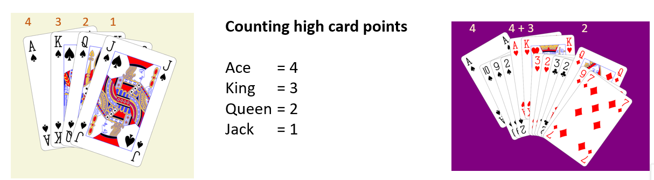

and that total, coupled with the ‘shape’ of the hand, determines whether or not they wish to enter the **Bidding** at all, and how far they wish to go. When the final, largest bid has been made, that Pair are the **Declarers**, and the first one of the Declarers to mention that chosen denomination – be it an actual Suit, or No Trumps - is the ***Declarer***. Play now begins. The person on the Declarer’s left chooses the card from his 13 as the opening lead, and Declarer’s partner places his cards face-up on the Table for all to see – this is called the ***Dummy***. Declarer plays from both hands, and dummy is now inactive. When all 13 cards are played, the number of Tricks made by Declarer determines the success or failure of the Contract. This result, in a Competition, is either recorded electronically, or entered into a Scoresheet which is hidden until the hand is played.

In a competition, the Pairs move around to all of the Tables and play against the other Pairs, with different Sets of Boards The number of Boards in a set will vary, and typically is dependent upon the number of Pairs playing. This competition is called ***Duplicate Contract Bridge***, and is the format used in most Bridge clubs.